**Principal Component Analysis (PCA) for Data Visualization**

**1.Introduction**

**What is PCA?**

*Principal Component Analysis (PCA) is a statistical technique designed to reduce the dimensionality of high-dimensional datasets*. By transforming the data into a smaller set of orthogonal components, PCA retains as much of the original variance as possible. This makes it an indispensable tool for simplifying and analyzing complex datasets, enabling deeper insights into their underlying structure.

**Why Use PCA?**

PCA is widely adopted in data analysis and machine learning due to its numerous benefits:

1. **Dimensionality Reduction**: Simplifies data representation, reducing computational costs and storage requirements.
2. **Visualization**: Projects high-dimensional data into 2D or 3D, facilitating visual exploration and interpretation.
3. **Noise Filtering**: Isolates components with the most variance, effectively minimizing irrelevant details and noise.
4. **Feature Creation**: Generates new, uncorrelated features that encapsulate meaningful patterns in the data.

**Importance in Data Visualization**

High-dimensional datasets are inherently challenging to interpret. PCA addresses this by projecting the data onto a lower-dimensional space while preserving its core structure. This reduction uncovers patterns, clusters, and outliers that may otherwise remain obscured in higher dimensions.

**Objectives of This Tutorial**

This tutorial is designed to:

1. Provide a comprehensive explanation of the theoretical foundations of PCA.
2. Illustrate its practical implementation using Python.
3. Highlight its application in data visualization through concrete examples.
4. Offer best practices to ensure the effective and reliable use of PCA in real-world scenarios.

# 2. Mathematical Foundations

## Data Standardization

Before applying PCA, it is essential to standardize the data to ensure all features contribute equally to the analysis. Without standardization, features with larger magnitudes could dominate the principal components, leading to biased results. Standardization transforms the data such that each feature has a mean of 0 and a standard deviation of 1.

The standardization formula is:

$$X_{\left(standardized\right)}=\frac{X-μ}{σ}$$

where X is the original feature value, $(μ)$ is the mean, and $(σ)$ is the standard deviation of the feature.

## Covariance Matrix

The covariance matrix measures the relationships between pairs of features, indicating how changes in one feature correspond to changes in another. This matrix is critical for PCA, as it reveals the directions (eigenvectors) and magnitudes (eigenvalues) of variance in the data.

The covariance matrix is computed as:

$$\text{Cov}\left(X\right)=\frac{1}{n-1}X^{T}X$$

Here, $(X)$ is the standardized data matrix, $(X^{T})$ is its transpose, and $(n)$ is the number of observations.

## Eigenvalues and Eigenvectors

Eigenvalues and eigenvectors are derived from the covariance matrix and are fundamental to PCA. They represent:

• Eigenvalues $\left((λ)\right) :$ Indicate the amount of variance captured by each principal component.  
• Eigenvectors $\left((v)\right):$ Define the directions of the principal components.

The eigenvalue equation is:

$$Av=λv$$

where $(A)$ is the covariance matrix, $(λ)$ is the eigenvalue, and $(v)$ is the eigenvector.

## Principal Components

Principal components are linear combinations of the original variables that maximize variance. They are computed by projecting the data onto the eigenvectors.

The formula for the $(i)-th$ principal component is:

$$PC_{i}=X⋅v_{i}$$

where $(X)$ is the standardized data and $(v_{i})$ is the eigenvector corresponding to the $(i)-th$ eigen value.

**Step-by-Step PCA Workflow**

1. **Standardize Data**: Normalize the dataset to ensure all features have a mean of zero and a standard deviation of one.
2. **Compute Covariance Matrix**: Calculate the relationships between features.
3. **Extract Eigenvalues and Eigenvectors**: Decompose the covariance matrix to identify directions and magnitudes of variance.
4. **Select Principal Components**: Retain the eigenvectors associated with the largest eigenvalues.
5. **Project Data**: Transform the original data into the space defined by the selected principal components.

**3. Practical Implementation in Python**

In this section, we’ll demonstrate how to apply PCA to the Iris dataset using Python. The steps include loading the dataset, standardizing features, performing PCA, and visualizing the results.

**Dataset Overview**

The Iris dataset contains measurements of sepal length, sepal width, petal length, and petal width for three species of flowers: ***Iris-setosa*, *Iris-versicolor***, and ***Iris-virginica***. PCA will reduce these four dimensions to two, enabling us to visualize the dataset in 2D.

**Steps to Implement PCA**

**1. Load the Dataset**

We use the **iris.data** file, which contains the measurements and species labels. Using pandas, we load the data and assign column names for clarity. A quick preview confirms the dataset is clean and well-structured.

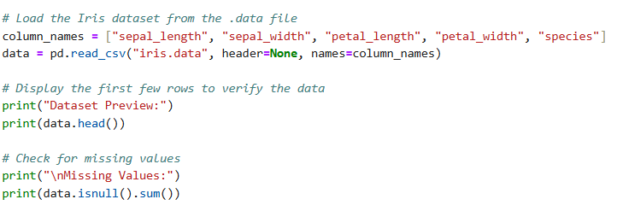

**Dataset Loading and Validation Outputs**

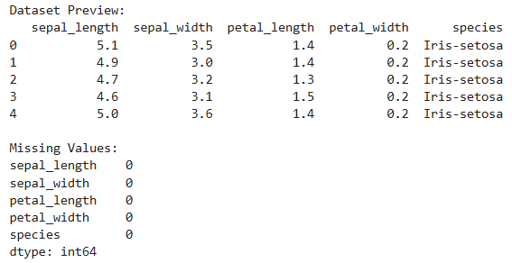

Figure 1: Dataset Preview and Missing Values Check. The dataset contains no missing values, and each feature is represented clearly.

**2. Standardize Features**

Before applying PCA, the features are standardized to ensure equal contribution from all dimensions.

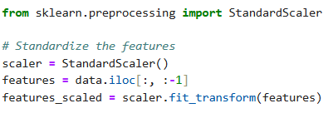

**3. Apply PCA**

Using the PCA module from scikit-learn, we reduce the dataset to two dimensions. We also calculate the explained variance ratio to understand how much information each principal component retains.

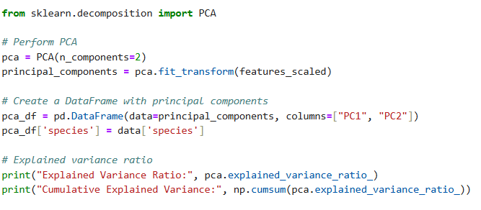 **Explained Variance**

The explained variance ratio quantifies how much of the original variance is captured by each principal component. For the Iris dataset:

* **Principal Component 1 (PC1)**: Captures approximately **72.8%** of the total variance, making it the most significant contributor to the dataset's variance.
* **Principal Component 2 (PC2)**: Captures around **23%** of the total variance.
* **Combined Variance**: Together, these two components account for approximately **95.8%** of the total variance. This demonstrates that PCA effectively reduces the dataset's dimensionality while retaining most of the important information.

This high percentage ensures that the two-dimensional representation preserves the majority of the dataset's structure, enabling effective visualization and analysis.

**PCA Transformation and Explained Variance Outputs**



**Figure 2**: *Dataset Preview, Missing Values Check, and Explained Variance for the Iris Dataset. The cumulative explained variance demonstrates that the first two principal components retain 95.8% of the dataset’s original information*

**4. Visualize Results in 2D**

We plot the two principal components to visualize the separation of species. Each cluster in the plot corresponds to a species, color-coded for clarity.

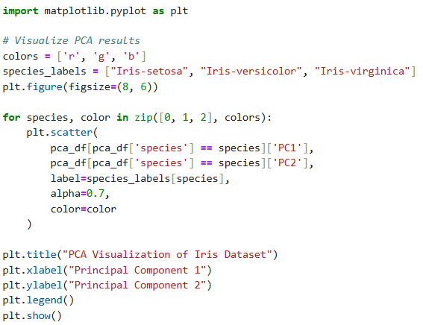

**Interpreting the Visualization**

The scatter plot shows the three species distributed across the two principal components:

1. **Distinct Clusters**: ***Iris-setosa*** forms a clearly defined cluster, **while *Iris-versicolor*** and ***Iris-virginica*** overlap slightly, indicating some similarities in their features.
2. **Dimensionality Reduction**: By reducing from four dimensions to two, PCA makes it possible to visualize relationships and differences between species effectively.

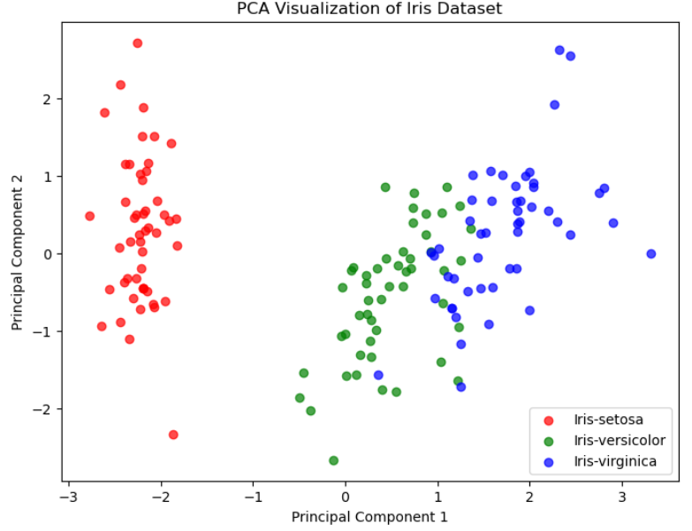

**Figure 3 :** *PCA Scatter Plot of the Iris Dataset: The two principal components account for 95.8% of the total variance, effectively separating the three species (Iris-setosa, Iris-versicolor, and Iris-virginica) into distinct clusters.*

**4. Applications and Use Cases**

PCA, a dimensionality reduction technique, has become indispensable in fields such as marketing, finance, and bioinformatics for simplifying complex datasets. Below are key applications that demonstrate its utility:

**1. Exploratory Data Analysis (EDA)**

PCA simplifies high-dimensional data, enabling analysts to uncover patterns and groupings. By projecting data into a lower-dimensional space, PCA reveals clusters and outliers that may otherwise remain hidden.

**Example**: In the Iris dataset, PCA helps visualize clusters corresponding to different species, assisting in early-stage exploratory analysis.

**2. Dimensionality Reduction in Machine Learning**

High-dimensional datasets can lead to overfitting and increased computational costs in machine learning models. PCA reduces the number of features, retaining only the most significant ones, which improves model performance and efficiency.

**Example**: In text classification, PCA reduces word embeddings to a manageable size, enabling faster training without losing critical information.

**3. Noise Filtering**

PCA focuses on components with high variance, effectively discarding less informative components that often represent noise. This improves data quality and robustness of downstream analysis.

**Example**: In audio signal processing, PCA isolates meaningful sound frequencies, filtering out background noise.

**4. Data Compression**

PCA reduces storage and computational costs by representing data with fewer dimensions while preserving most of its variance. This is especially useful for large datasets, such as images.

**Example**: PCA compresses high-resolution images, reducing their size while maintaining sufficient detail for visualization or analysis.

**5. Feature Engineering**

PCA generates uncorrelated features (principal components) that often reveal latent structures in data. These new features can improve model accuracy and interpretability.

**Example**: In financial analysis, PCA reduces correlated stock market indicators into a few principal components representing key trends.

**6. Visualization of High-Dimensional Data**

PCA transforms datasets with many features into 2D or 3D, allowing for intuitive visualization of patterns and relationships. This is particularly valuable for presentations and exploratory tasks.

**Example**: PCA reduces customer behavioral data with dozens of features to two components, enabling marketers to visualize customer segments.

**Real-World Example**

Imagine a dataset containing sensor readings from manufacturing equipment:

* PCA reduces hundreds of sensor features to a few critical components for easier monitoring and analysis.
* Noise is removed, improving the accuracy of predictive maintenance models.
* Compressed data is stored more efficiently, saving computational resources.

PCA’s ability to simplify data while retaining its essence makes it a fundamental tool in data science. From EDA to machine learning, its applications highlight the importance of dimensionality reduction in real-world scenarios.

**5. Best Practices for Effective PCA**

While PCA is a powerful tool, its effectiveness depends on how it is applied. Following these best practices ensures reliable results and interpretable outputs:

**1. Standardize Data**

Standardizing data is a critical first step in PCA. Features with larger scales can dominate the analysis, skewing the results. By standardizing data to have zero mean and unit variance, you ensure that all features contribute equally to the principal components.

**Tip**: Always standardize your dataset before applying PCA, especially when working with features measured in different units (e.g., height in meters and weight in kilograms).

**2. Select Components Using Explained Variance**

The explained variance ratio indicates how much information each principal component retains. Choose the number of components that capture a sufficient proportion of the total variance (e.g., 95%) to balance dimensionality reduction and data fidelity.

**Tip**: Use a cumulative variance plot to identify the optimal number of components. For the Iris dataset, two components explaining ~95.8% of variance are often sufficient.

**3. Interpretability vs. Complexity**

Reducing dimensions simplifies datasets but can make the transformed features less interpretable. While PCA captures variance, it doesn’t maintain the original feature meanings. Balance dimensionality reduction with the need for interpretable results.

**Tip**: For applications requiring interpretability, consider combining PCA with domain knowledge or retaining original features alongside components.

**4. Validate Results**

Visualizations are crucial for interpreting PCA. Scatter plots of principal components help identify clusters, trends, and separations in the data. Additionally, validate PCA results by comparing performance before and after dimensionality reduction in machine learning tasks.

**Tip**: Always inspect explained variance ratios and visualizations to ensure PCA is capturing the underlying structure effectively.

By following these best practices, you can leverage PCA to its fullest potential, ensuring that reduced dimensions retain meaningful insights without compromising accuracy or interpretability.

**6. Conclusion**

Principal Component Analysis (PCA) is a fundamental tool in data science, offering a powerful way to simplify high-dimensional data while retaining its essential structure. By reducing dimensions, PCA not only improves computational efficiency but also enables effective visualization, making it easier to uncover patterns, clusters, and outliers.

This tutorial has demonstrated how to implement PCA in Python, covering key steps like standardizing data, computing principal components, and visualizing results. Through practical examples, we’ve highlighted PCA’s utility in exploratory data analysis, noise filtering, dimensionality reduction, and feature engineering.

PCA’s versatility makes it valuable in diverse real-world applications, from compressing images to enhancing machine learning models. As a next step, you are encouraged to experiment with PCA on new datasets, exploring its potential to simplify complex problems and uncover hidden insights.

**7.Resources**

To supplement this tutorial, the following resources provide access to the code and interactive implementation:

**GitHub Repository**

The code, dataset, and PDF tutorial for this project are available on GitHub. You can explore, download, or clone the repository to try it out locally: [**PCA-Tutorial Repository**](https://github.com/SHAIKSONY1/PCA-Tutorial/tree/main)

**Run the Code on Google Colab**

To experiment with the code interactively and execute it step-by-step in a browser, use the Google Colab notebook: [**Iris Dataset PCA Analysis - Colab Notebook**](https://colab.research.google.com/drive/11vGDsfYTewYvubg5AmZTdmw0s8W8J1km?usp=sharing)**.**

These resources are designed to make the implementation of PCA accessible and adaptable for your projects.

**8.References**

Fisher, R.A. (n.d.). *UCI Machine Learning Repository*. [online] archive.ics.uci.edu. Available at: <https://archive.ics.uci.edu/dataset/53/iris>.

Zhao, H., Lai, Z., Leung, H. and Zhang, X. (2020). Principal Component Analysis. *Information Fusion and Data Science*, pp.31–52. doi:https://doi.org/10.1007/978-3-030-40794-0_3.

Naik, G.R. (2017). *Advances in Principal Component Analysis*. [online] *Springer eBooks*. Springer Nature. doi:https://doi.org/10.1007/978-981-10-6704-4.

scikit-learn (2009). *sklearn.decomposition.PCA — scikit-learn 0.20.3 documentation*. [online] Scikit-learn.org. Available at: <https://scikit-learn.org/stable/modules/generated/sklearn.decomposition.PCA.html>.

Hunter, J.D. (2007). Matplotlib: A 2D Graphics Environment. *Computing in Science & Engineering*, 9(3), pp.90–95.

Ieee.org. (2024). *IEEE Xplore Full-Text PDF:* [online] Available at: <https://ieeexplore.ieee.org/stamp/stamp.jsp?arnumber=9483946>.

Jolliffe, I.T. (2002). *Principal Component Analysis*. [online] *Springer Series in Statistics*. New York: Springer-Verlag. doi:https://doi.org/10.1007/b98835.

‌

‌